Test Plan (XSM)

Test Plan 1
Objective 2
Scope 2
Inclusions 4
Test Environments 6
Defect Reporting Procedure 7
Test Strategy 8
Test Schedule 9
Test Deliverables. 10
Entry and Exit Criteria 10
Entry Criteria: 10
Exit Criteria: 11
Test Execution 11
Entry Criteria: 11
Exit Criteria: 11
Test Closure 11
Entry Criteria: 11
Exit Criteria: 11
Tools 11
Risks and Mitigations 11
Approvals 12

Objective
In this document of the Test Plan for the XSM application, covering service management workflows including Change, Incident and Service Request handling

Import and aggregate all metrics you care about and measure how they get impacted by your experiments.

Track both leading and lagging indicators for your experiment's impact
Keep an eye on guardrail metrics to stop bad experiments early on

- React 18.2.0
- jQuery 2.1.1
- JavaScript
- Database Postgres SQL
- Web Server (Apache suggested)
- Nginx

Scope

The features and functionality of XSM that will be tested, such as the user interface, change management workflows, incident handling, approval routing, and cross-browser compatibility.

The types of testing that will be performed, such as manual testing, automated testing, performance testing, and accessibility testing.

The environments in which testing will be conducted, such as different browsers, operating systems, and device types.

The criteria that will be used to evaluate the success of the testing, such as the number of defects found, the time taken to complete the testing, and user satisfaction ratings.

The roles and responsibilities of the team members involved in the testing, such as the test lead, testers, and developers.

The schedule and milestones for the testing, including the start and end dates, and the planned testing activities.

The tools and equipment that will be used for testing, such as testing software, hardware, and documentation templates.

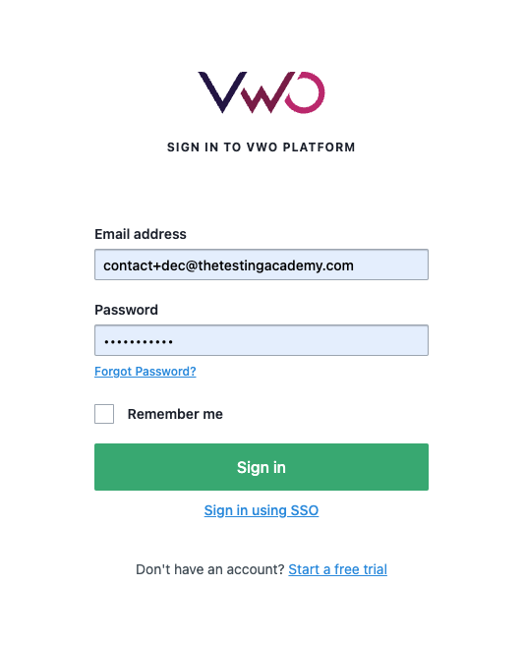

Inclusions

Introduction: This section would provide an overview of the test plan, including its purpose, scope, and goals.

Test Objectives: This section would outline the specific objectives of the testing, such as identifying and fixing defects, improving the user experience, or achieving a certain level of performance.

- Login
- Dashboard Page
- Create new Campaign
- Editor
- Run on a Website

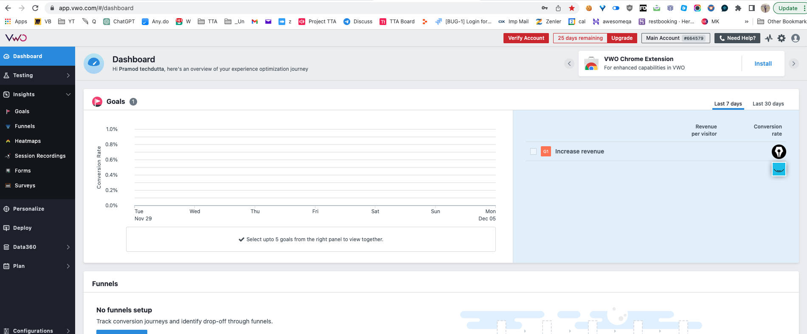

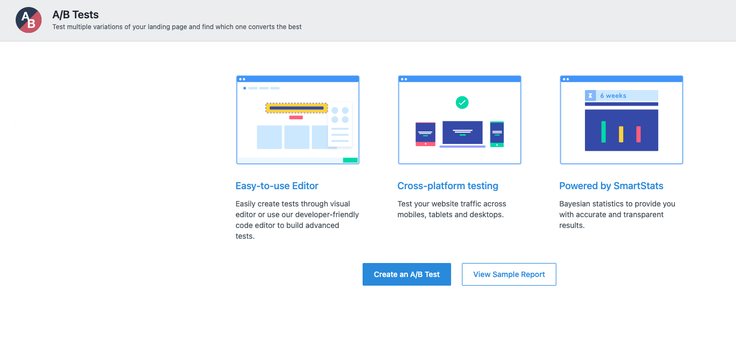

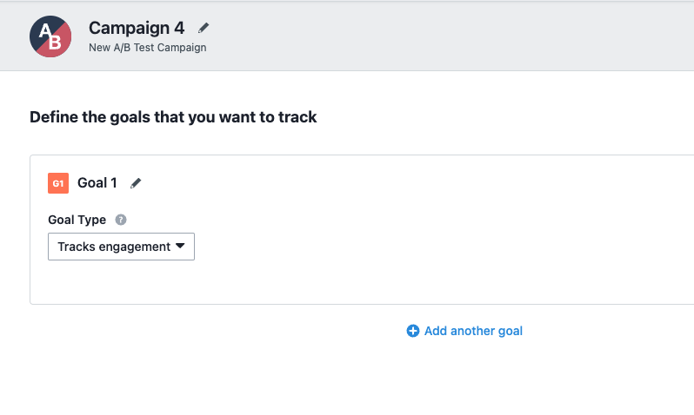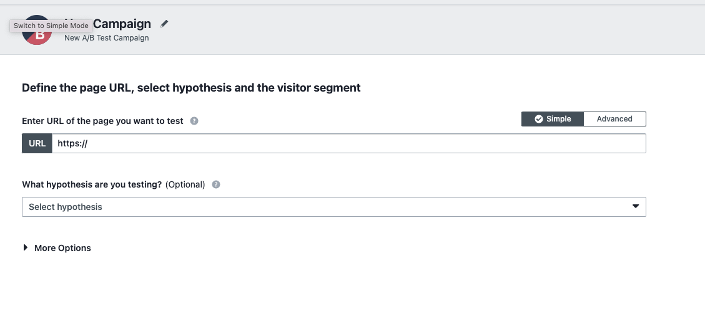

Test Environments

The operating systems and versions that will be used for testing, such as Windows 10, macOS, or Linux.

The browsers and versions that will be tested, such as Google Chrome, Mozilla Firefox, or Microsoft Edge.
The device types and screen sizes that will be used for testing, such as desktop computers, laptops, tablets, and smartphones.

The network connectivity and bandwidth that will be available for testing, such as Wi-Fi, cellular, or wired connections.

The hardware and software requirements for running the test cases, such as a specific processor, memory, or storage capacity.

The security protocols and authentication methods that will be used to access the test environment, such as passwords, tokens, or certificates.

The access permissions and roles of the team members who will be using the test environment, such as testers, developers, or stakeholders.

Name | Env url
QA | https://xsmtest.dryice-aws.com/
Pre Prod | https://xsmtest.dryice-aws.com/
UAT | https://xsmtest.dryice-aws.com/
Prod | https://xsmtest.dryice-aws.com/

Windows 10 – Chrome, Firefox and Edge
• Mac OS – Safari Browser
• Android Mobile OS – Chrome
• iPhone Mobile OS - Safari

Defect Reporting Procedure

The criteria for identifying a defect, such as deviation from the requirements, user experience issues, or technical errors.

The steps for reporting a defect, such as using a designated template, providing detailed reproduction steps, and attaching screenshots or logs.

The process for triaging and prioritizing defects, such as assigning severity and priority levels, and assigning them to the appropriate team members for investigation and resolution.

The tools and systems that will be used for tracking and managing defects, such as a defect tracking software or a project management tool.

The roles and responsibilities of the team members involved in the defect reporting process, such as testers, developers, and the test lead.

The communication channels and frequencies for updating stakeholders on the progress and status of defects.

The metrics and metrics that will be used to measure the effectiveness of the defect reporting process, such as the number of defects found, the time taken to resolve them, and the percentage of defects that were successfully fixed.

Defect Process | POC
New Frontend | TBD
Backend | TBD
Dev Ops | TBD

Tools - JIRA

Test Strategy

The first step is to create test scenarios and test cases for the various features in
Scope.

While developing test cases, we'll use a number of test design techniques.
o Equivalence Class Partition
o Boundary Value Analysis
o Decision Table Testing
o State Transition Testing
o Use Case Testing

We also use our expertise in creating Test Cases by applying the below:
o Error Guessing
o Exploratory Testing
• We prioritize the Test Cases

Step 2: Our testing procedure when we receive a request for testing:

• First, we'll conduct smoke testing to see if the various and
important functionalities of the application are working.

• We reject the build, if the Smoke Testing fails and will wait for the stable
build before performing in depth testing of the application functionalities.

• Once we receive a stable build, which passes Smoke Testing, we perform
in depth testing using the Test Cases created.

• Multiple Test Resources will be testing the same Application on Multiple
Supported Environments simultaneously.

We then report the bugs in bug tracking tool and send dev. management
the defect found on that day in a status end of the day email.

As part of the Testing, we will perform the below types of Testing:
o Smoke Testing and Sanity Testing
o Regression Testing and Retesting
o Usability Testing, Functionality & UI Testing
• We repeat Test Cycles until we get the quality product.

Step3 – We will follow the below best practices to make our Testing better:

• Context Driven Testing – We will be performing Testing as per the context
of the given application.

• Shift Left Testing – We will start testing from the beginning stages of the
development itself, instead of waiting for the stable build.

• Exploratory Testing – Using our expertise we will perform Exploratory
Testing, apart from the normal execution of the Test cases.

• End to End Flow Testing – We will test the end-to-end scenario which
involve multiple functionalities to simulate the end user flows.

Test Schedule

Following is the test schedule planned for the project –
Task Time Duration

Task | Dates
▪ Creating Test Plan
▪ Test Case Creation
▪ Test Case Execution
▪ Summary Reports Submission Date

2 Sprints to Test the Application

Test Deliverables.

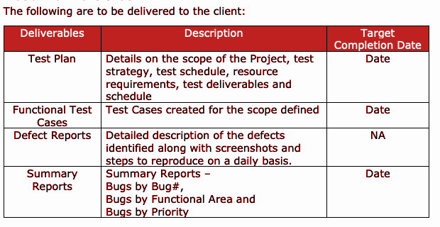

Entry and Exit Criteria
The below are the entry and exit criteria for every phase of Software Testing Life
Cycle:
Requirement Analysis

Entry Criteria:
• Once the testing team receives the Requirements Documents or details
about the Project

Exit Criteria:
• List of Requirements are explored and understood by the Testing team
• Doubts are cleared

Test Execution

Entry Criteria:
• Test Scenarios and Test Cases Documents are signed-off by the Client
• Application is ready for Testing

Exit Criteria:
• Test Case Reports, Defect Reports are ready

Test Closure

Entry Criteria:
• Test Case Reports, Defect Reports are ready

Exit Criteria:
• Test Summary Reports

Tools
The following are the list of Tools we will be using in this Project:
• JIRA Bug Tracking Tool
• Mind map Tool
• Snipping Screenshot Tool
• Word and Excel documents

Risks and Mitigations
The following are the list of risks possible and the ways to mitigate them:
Risk: Non-Availability of a Resource
Mitigation: Backup Resource Planning
Risk: Build URL is not working
Mitigation: Resources will work on other tasks
Risk: Less time for Testing
Mitigation: Ramp up the resources based on the Client needs dynamically

Approvals
Team will send different types of documents for Client Approval like below:
• Test Plan
• Test Scenarios
• Test Cases
• Reports
Testing will only continue to the next steps once these approvals are done

